**Week of June 04 – June 07**

This report covers all the tweets sent between June 04 – June 07 that mentioned “NickForVA”.

##### How many are retweets?  
   
 table(VA.tweetdf$isRetweet)

##   
## FALSE TRUE   
## 1765 3603

The conversation was dominated by retweets, accounting for 3603 out of 5368, or 67.1%, of the total tweets.

**Top Tweets using “NickForVA”**

The following is an output of all the top 6 tweets with the most favorites and the most retweets in the tweets collection.

A screenshot of the tweets that have both highest favorites and retweets are below for visualization. In most cases, the same tweets made the list of top favorites and top retweets, so only visualization is provided.

**list of top 6 favorited retweet by NickForVA**

## text  
## 1 Thanks to everyone who has recently announced support for our campaign. It’s especially humbling to have a positive… https://t.co/iap2xBuHdL  
## 2 It was an honor to talk with @KyleKashuv on school security.\n\nWe need to focus on those security measures which we… https://t.co/BgiruAfuPy  
## 3 I happily accept the invitation. https://t.co/NcIxjwLzOt  
## 4 "U.S. Sen. Rand Paul (R-Ky.) will be in Loudoun County this weekend in support of Virginia Del. Nick Freitas’ run f… https://t.co/v0dxHbWMqf  
## 5 Don’t forget! The GOP primary election is only 8 DAYS away.\n\nTo learn more ➡️ https://t.co/Xk7thjgIgj https://t.co/3QN3Lbpued  
## 6 "Ultimately I believe everyone in this room is uniquely and wonderfully created. You have a purpose that you are go… https://t.co/et92Pzi9HU  
## favoriteCount created screenName  
## 1 3336 2018-06-06 18:59:41 NickForVA  
## 2 974 2018-06-05 14:03:58 NickForVA  
## 3 528 2018-06-07 20:22:03 NickForVA  
## 4 489 2018-06-06 20:20:15 NickForVA  
## 5 431 2018-06-04 12:51:11 NickForVA  
## 6 394 2018-06-07 00:09:25 NickForVA

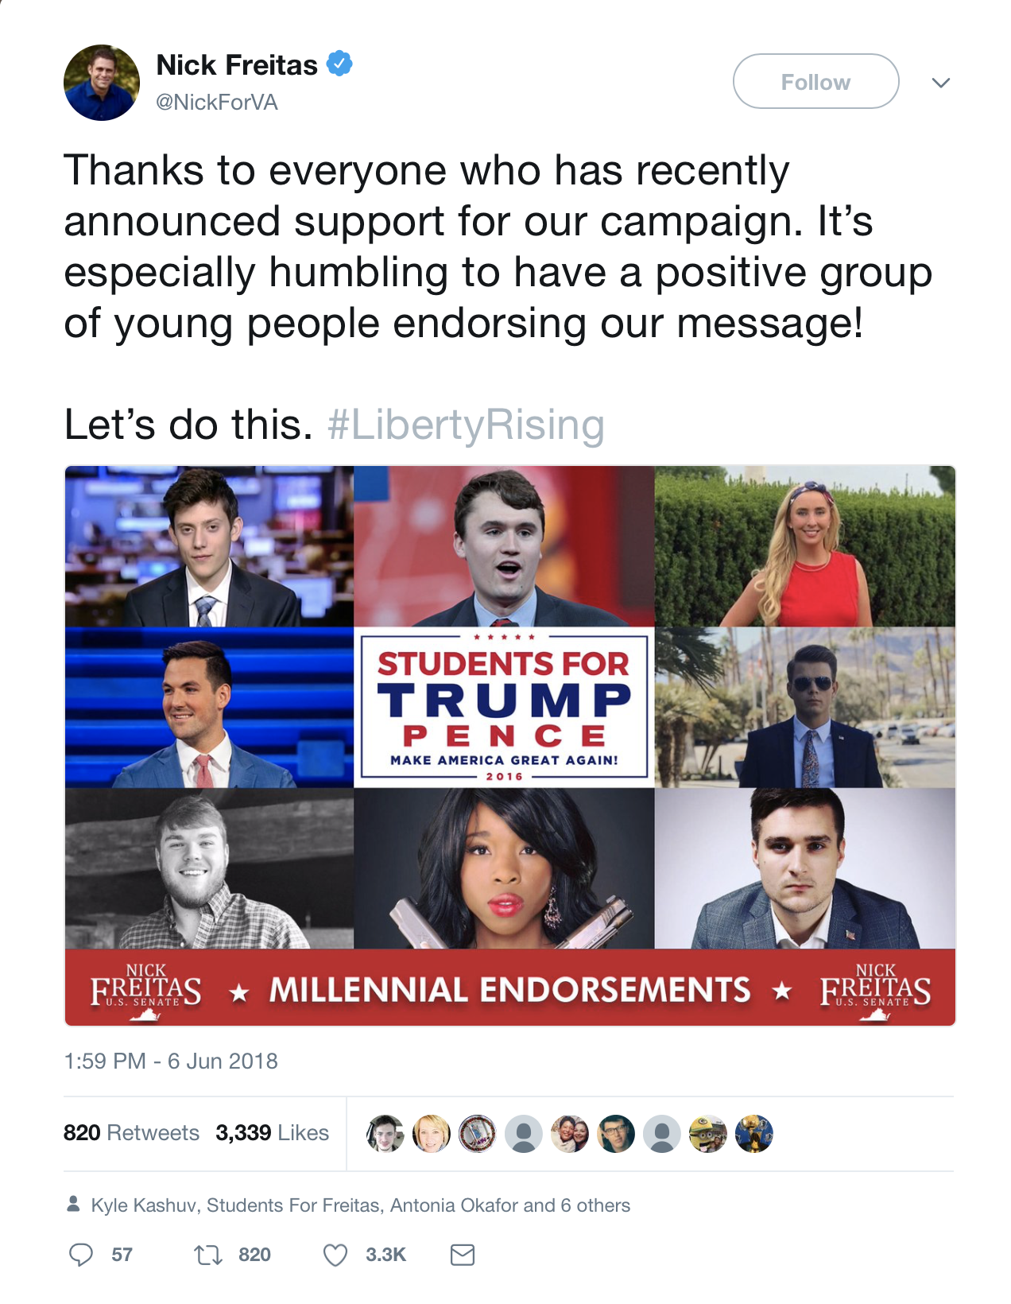

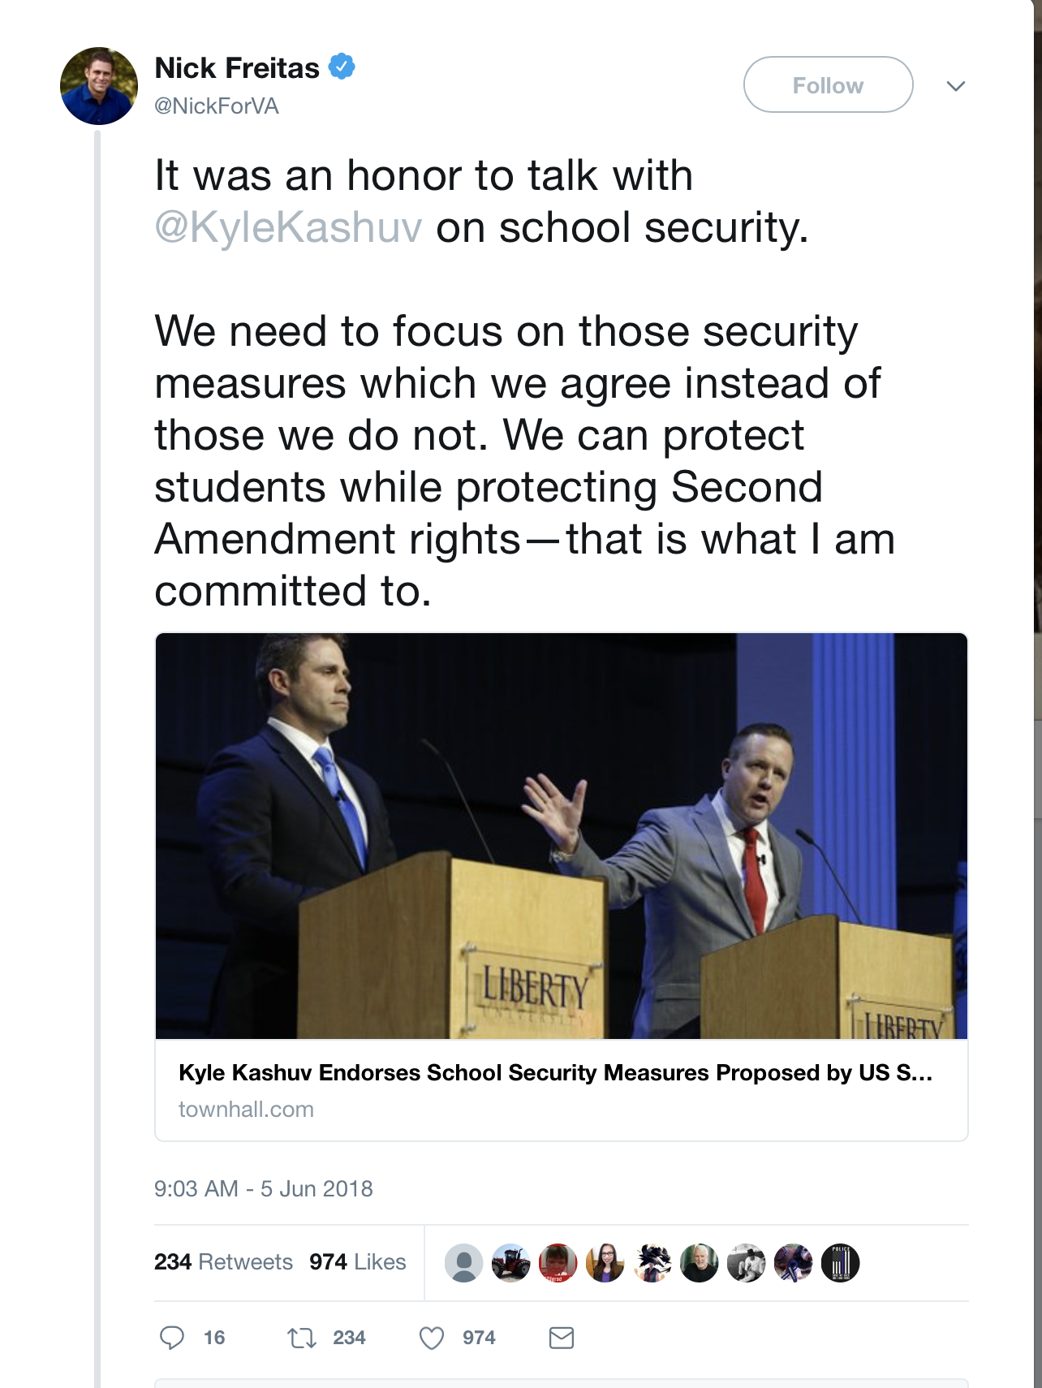

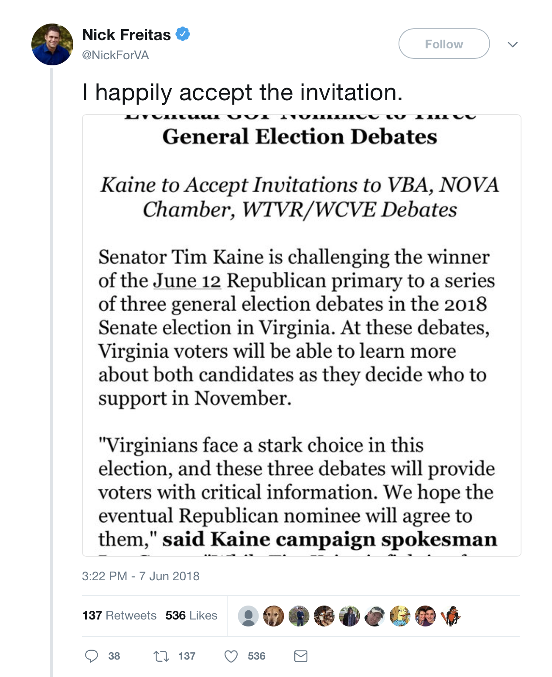

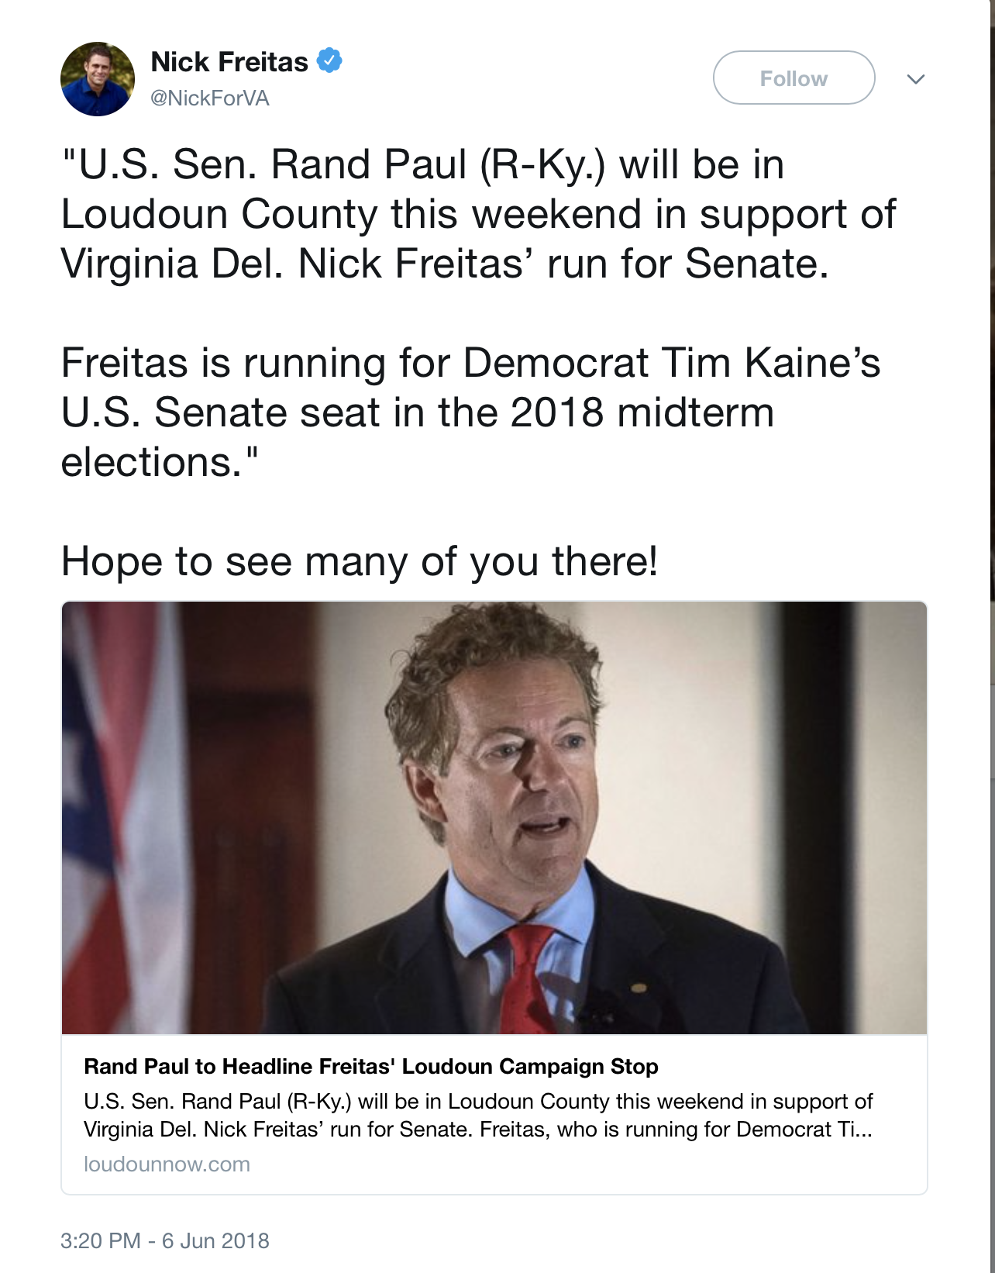

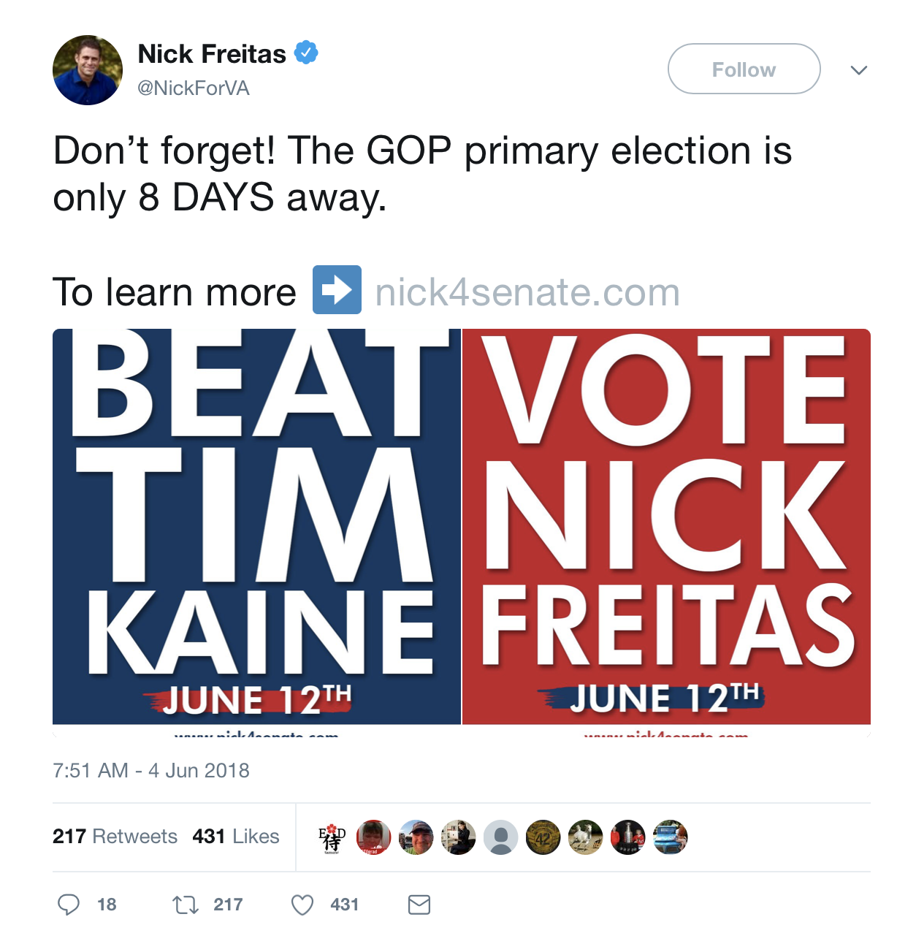

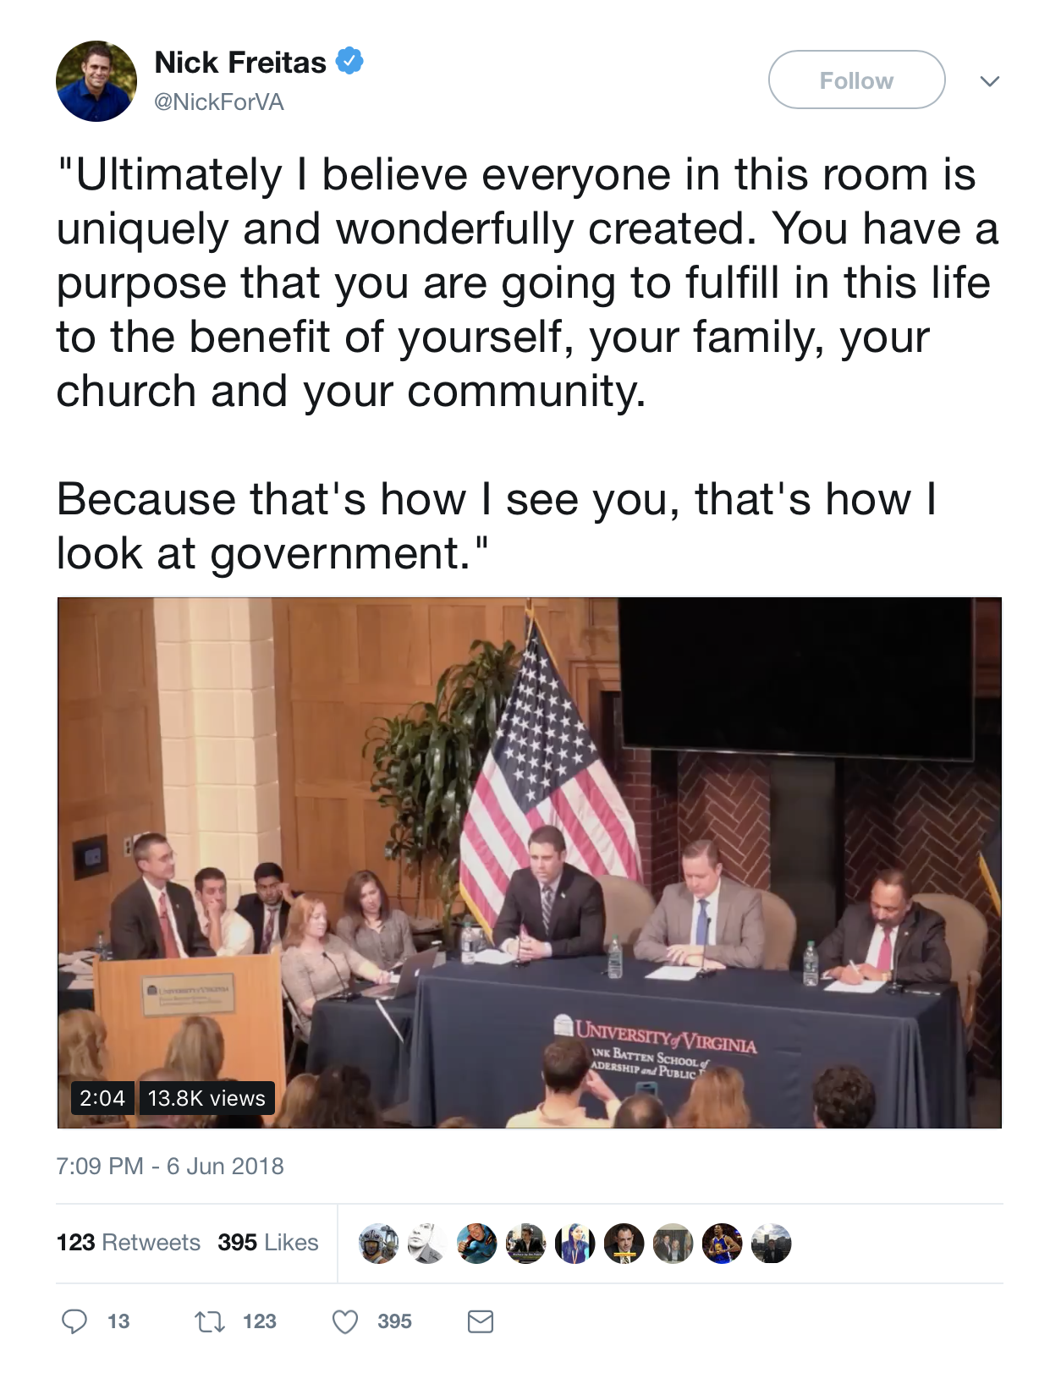

**other than from NickForVA account, most favorited**

text  
## 1 .@Stump_for_Trump knows who will fight for the President’s agenda! @NickForVA will #MAGA in the Senate and… https://t.co/yOyfWzaEL4  
## 2 Kyle Kashuv Endorses School Security Measures Proposed by US Senate Candidate @NickForVA https://t.co/DwroBbledG  
## 3 You had me at "Merit based immigration" I became seduced at "Secure the border" assuming that means building the wa… https://t.co/y52rss3H4a  
## 4 Proud to endorse this liberty lover! @NickForVA \xed\xa0\xbc\xed\xb7\xba\xed\xa0\xbc\xed\xb7\xb8 Virginia remember to vote this man in on June 12th. A man who de… https://t.co/B7KPu7zQ9H  
## 5 We are proud to enthusiastically support @NickForVA to be the next Virginia Senator. \n\nNick will be a strong princi… https://t.co/6DuXlFyBWa  
## 6 By the way, there’s a far better choice in the GOP primary than Corey Stewart: @NickForVA. https://t.co/XaiA6V7qQb  
## favoriteCount created screenName  
## 1 439 2018-06-04 15:12:23 FreitasStudents  
## 2 294 2018-06-05 07:26:43 KyleKashuv  
## 3 224 2018-06-04 03:09:12 GayRepublicSwag  
## 4 189 2018-06-06 19:03:09 antonia_okafor  
## 5 167 2018-06-04 18:04:19 ReaganBattalion  
## 6 122 2018-06-04 16:56:15 BillKristol

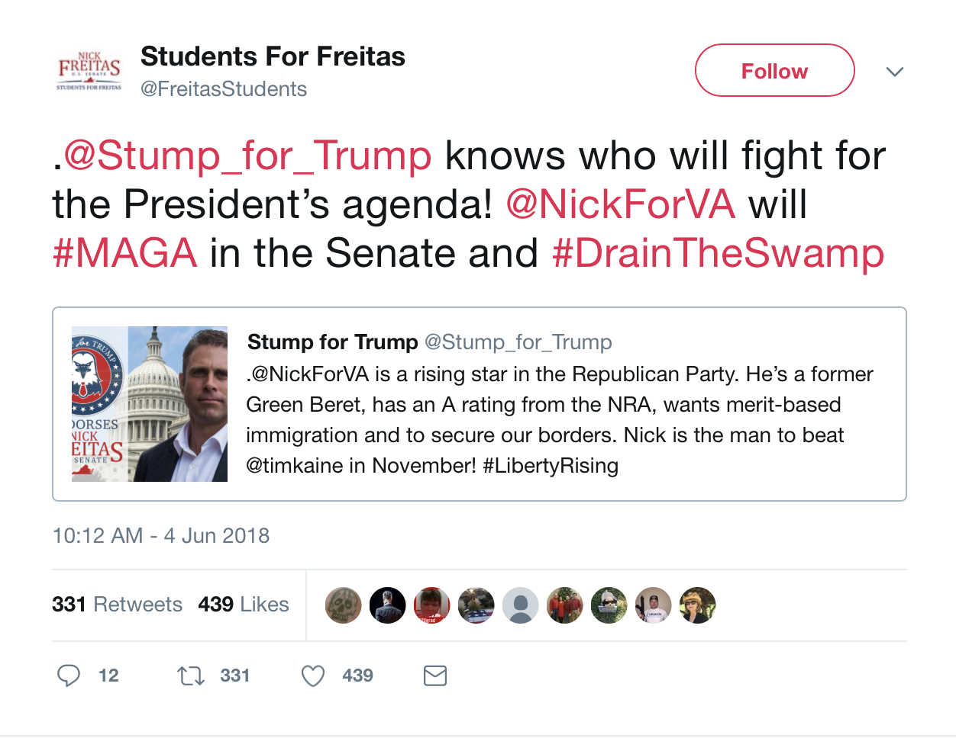

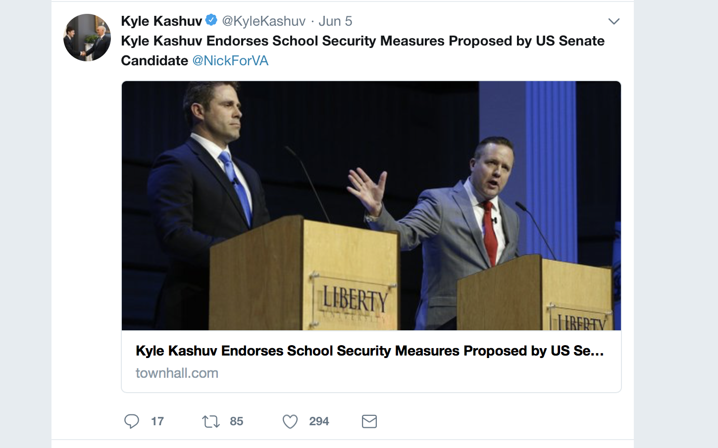

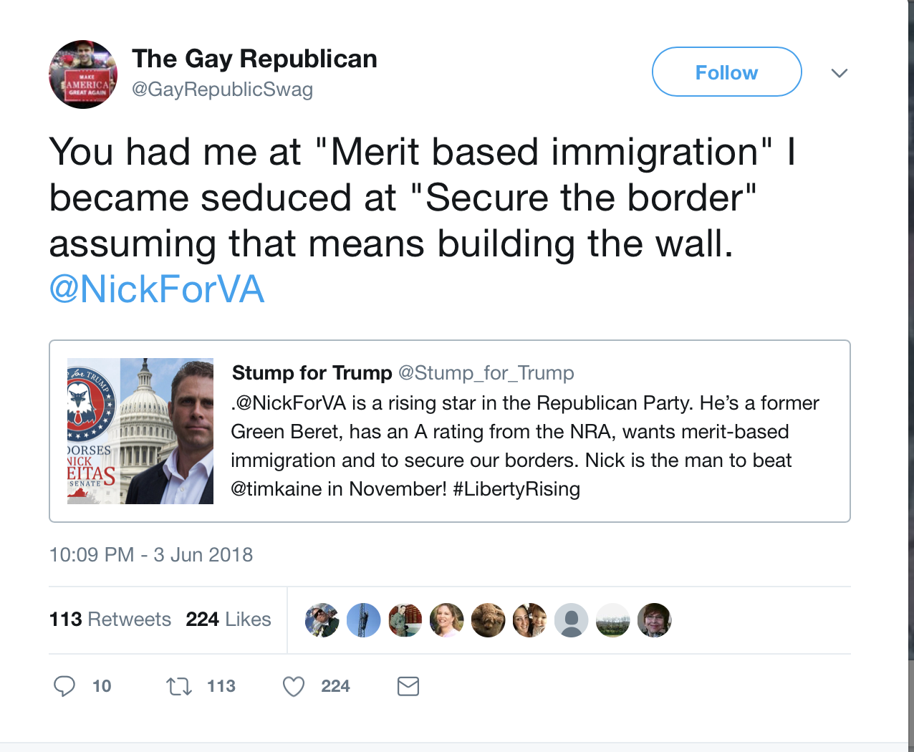

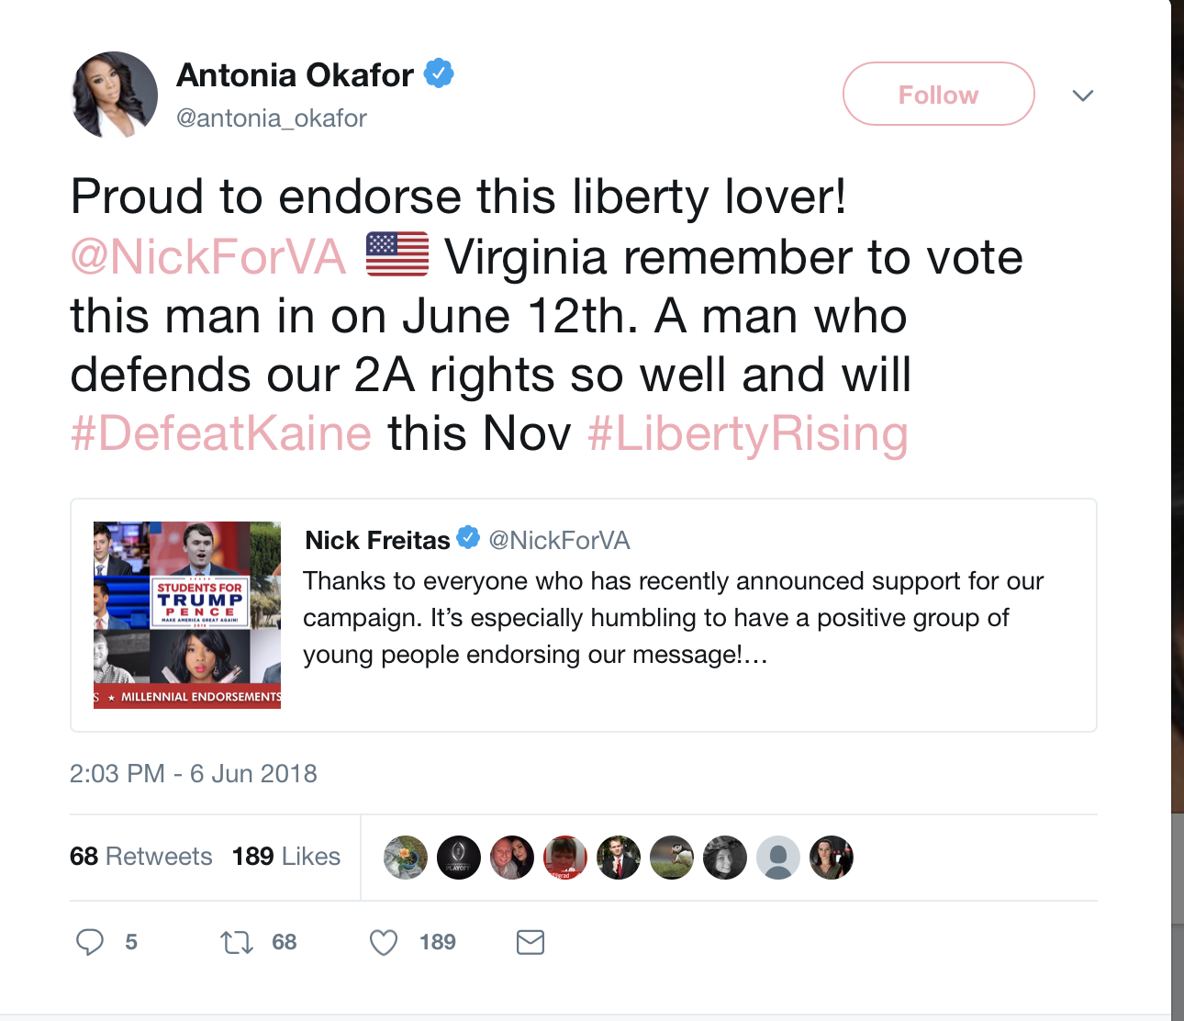

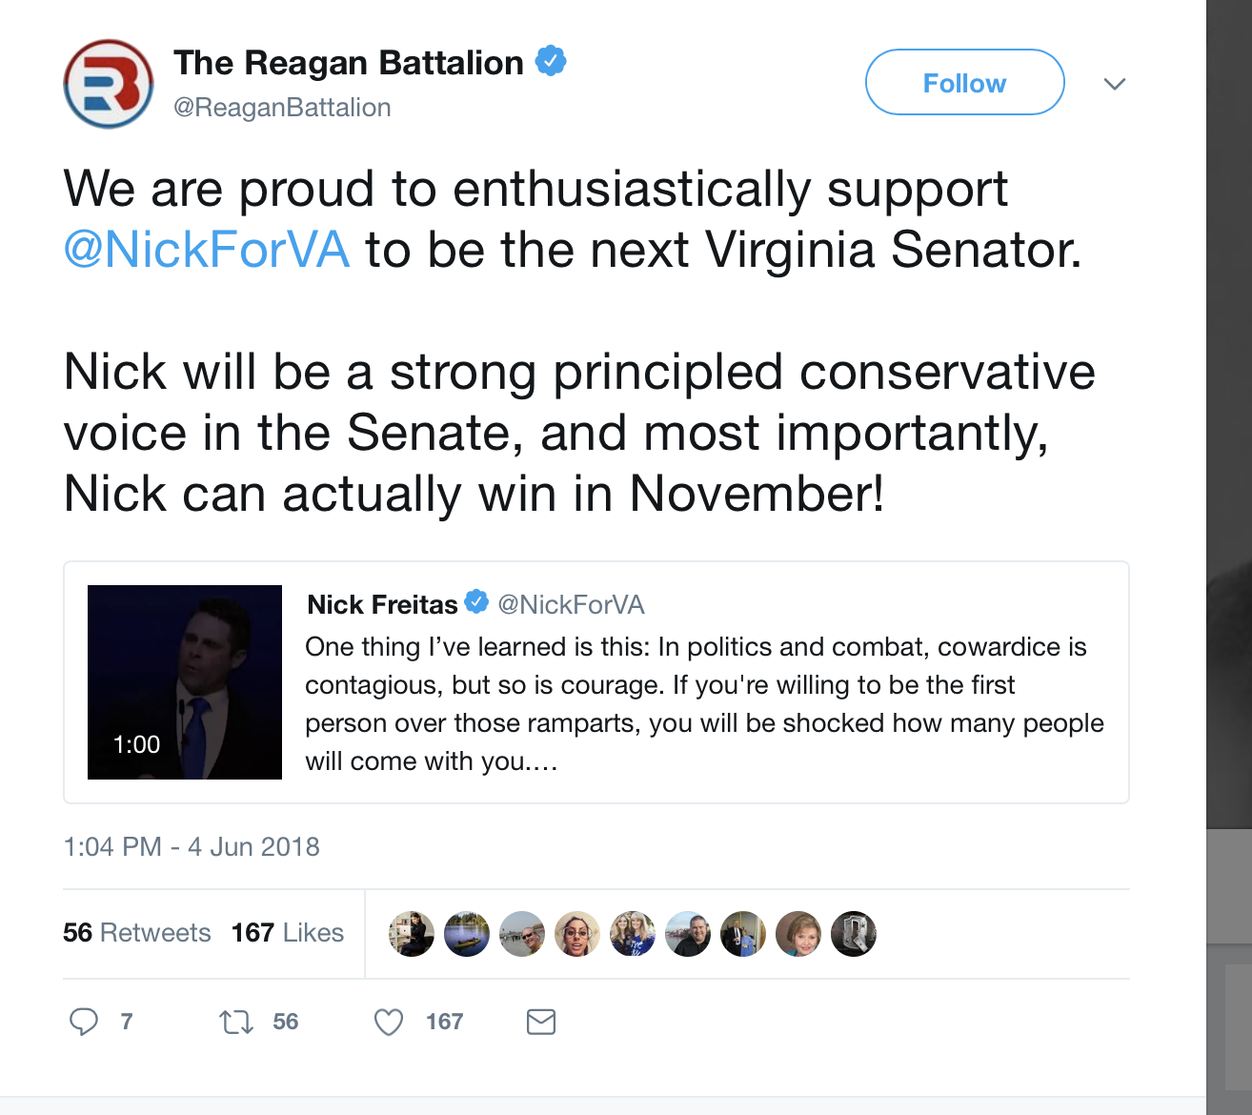

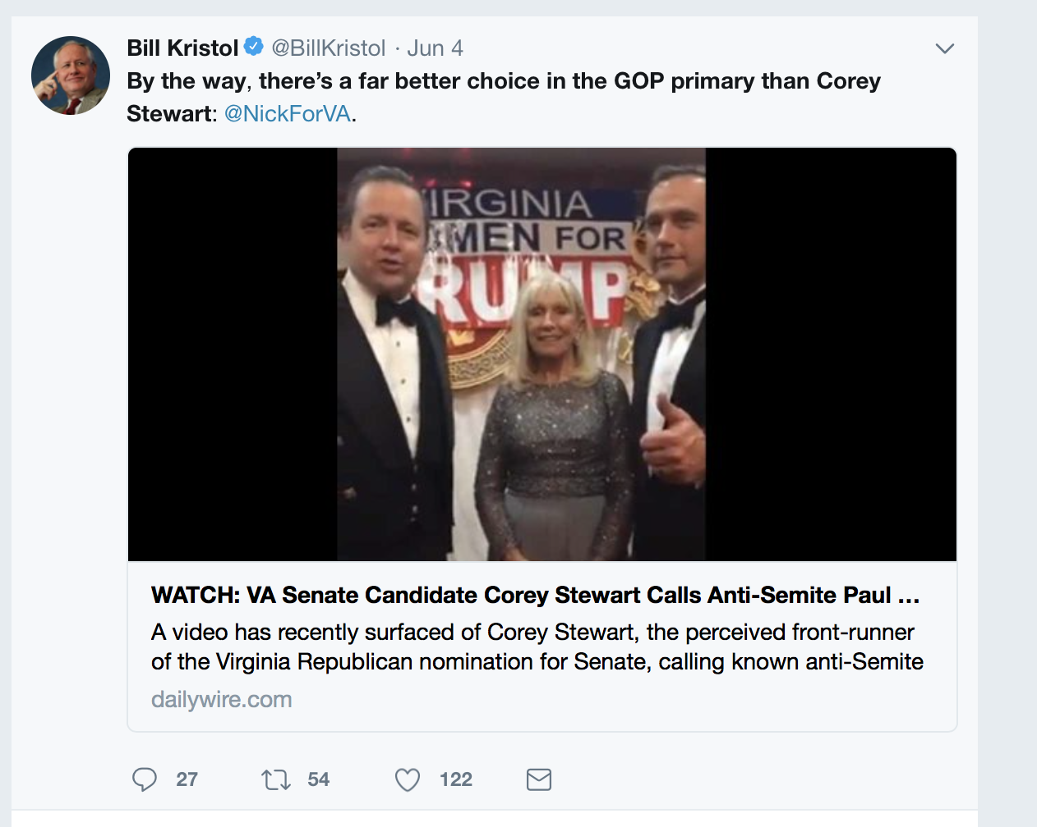

**top 6 retweeted tweet By NickForVA**

## text  
## 1 Thanks to everyone who has recently announced support for our campaign. It’s especially humbling to have a positive… https://t.co/iap2xBuHdL  
## 2 RT @AutumnDawnPrice: Thinking of the Bedford Boys this morning. Of the 35 young men who went to Normandy, 19 of them perished. \n\nDuring Wor…  
## 3 It was an honor to talk with @KyleKashuv on school security.\n\nWe need to focus on those security measures which we… https://t.co/BgiruAfuPy  
## 4 Don’t forget! The GOP primary election is only 8 DAYS away.\n\nTo learn more ➡️ https://t.co/Xk7thjgIgj https://t.co/3QN3Lbpued  
## 5 "U.S. Sen. Rand Paul (R-Ky.) will be in Loudoun County this weekend in support of Virginia Del. Nick Freitas’ run f… https://t.co/v0dxHbWMqf  
## 6 I happily accept the invitation. https://t.co/NcIxjwLzOt  
## retweetCount created screenName  
## 1 819 2018-06-06 18:59:41 NickForVA  
## 2 623 2018-06-06 13:35:17 NickForVA  
## 3 234 2018-06-05 14:03:58 NickForVA  
## 4 217 2018-06-04 12:51:11 NickForVA  
## 5 163 2018-06-06 20:20:15 NickForVA  
## 6 136 2018-06-07 20:22:03 NickForVA

# top 6 retweeted tweet Not from NickForVA

## text  
## 1 .@Stump_for_Trump knows who will fight for the President’s agenda! @NickForVA will #MAGA in the Senate and… https://t.co/yOyfWzaEL4  
## 2 You had me at "Merit based immigration" I became seduced at "Secure the border" assuming that means building the wa… https://t.co/y52rss3H4a  
## 3 Kyle Kashuv Endorses School Security Measures Proposed by US Senate Candidate @NickForVA https://t.co/DwroBbledG  
## 4 Proud to endorse this liberty lover! @NickForVA \xed\xa0\xbc\xed\xb7\xba\xed\xa0\xbc\xed\xb7\xb8 Virginia remember to vote this man in on June 12th. A man who de… https://t.co/B7KPu7zQ9H  
## 5 Please follow\xed\xa0\xbd\xed\xb1\x87\n@JDugudichi\n@DiehlForSenate\n@TrumpLovesMyUSA\n@MorriseyWV\n@TrumpLovesToWin\n@NickForVA\n@repmorgan… https://t.co/KKvHvYX7SK  
## 6 We are proud to enthusiastically support @NickForVA to be the next Virginia Senator. \n\nNick will be a strong princi… https://t.co/6DuXlFyBWa  
## retweetCount created screenName  
## 1 331 2018-06-04 15:12:23 FreitasStudents  
## 2 113 2018-06-04 03:09:12 GayRepublicSwag  
## 3 85 2018-06-05 07:26:43 KyleKashuv  
## 4 68 2018-06-06 19:03:09 antonia_okafor  
## 5 64 2018-06-04 11:44:23 JDugudichi  
## 6 56 2018-06-04 18:04:19 ReaganBattalion

### Top ten retweets overall

In this case, there were tweets that were created before the week that were still being shared on Twitter and accumulating retweets throughout the week.

These Tweets are tweets that have been explored in previous week’s report, so their visualizations were omitted.

## text  
## 1 RT @charliekirk11: Nick is a total stud and Tim Kaine might be one of the most repulsive US Senators out there\n\nNick can win and unseat Tim…  
## 2 RT @NickForVA: I fought to protect my country as a Green Beret. \n\nAs Delegate, I fought against special interests to preserve our liberty a…  
## 3 RT @Stump_for_Trump: .@NickForVA is a rising star in the Republican Party. He’s a former Green Beret, has an A rating from the NRA, wants m…  
## 4 RT @NickForVA: Thanks to everyone who has recently announced support for our campaign. It’s especially humbling to have a positive group of…  
## 5 Thanks to everyone who has recently announced support for our campaign. It’s especially humbling to have a positive… https://t.co/iap2xBuHdL  
## 6 RT @Patriotic_Va: #NickFreitas dropping truth bombs \xed\xa0\xbd\xed\xb2\xa5\xed\xa0\xbd\xed\xb2\xa5 about our #2A rights! @NickForVA sounding pretty solid! \n\n#Virginians get out there…  
## 7 RT @YALiberty: Virginia Delegate @NickForVA dropping truth bombs about the dialogue America needs. #MakeLibertyWin https://t.co/FYyzozmys2  
## 8 RT @AutumnDawnPrice: Thinking of the Bedford Boys this morning. Of the 35 young men who went to Normandy, 19 of them perished. \n\nDuring Wor…  
## 9 RT @NickForVA: We cannot accept another term of Tim Kaine &amp; his agenda.\n\nI've never stopped fighting for our conservative principles as a V…  
## 10 RT @NickForVA: One thing I’ve learned is this: In politics and combat, cowardice is contagious, but so is courage. If you're willing to be…  
## retweetCount created screenName isRetweet  
## 1 3041 2018-06-05 09:32:28 LAMOONLYNN TRUE  
## 2 1754 2018-06-07 11:39:03 Richard01702798 TRUE  
## 3 1583 2018-06-06 03:51:54 serphillipsbob TRUE  
## 4 819 2018-06-07 23:48:39 MangunsongGrace TRUE  
## 5 819 2018-06-06 18:59:41 NickForVA FALSE  
## 6 801 2018-06-07 23:40:00 Rainbojangles TRUE  
## 7 710 2018-06-07 10:27:05 Cardinal_Josh4 TRUE  
## 8 623 2018-06-06 13:35:17 NickForVA TRUE  
## 9 506 2018-06-07 17:11:46 flyboymcgee TRUE  
## 10 403 2018-06-07 22:28:12 billyboblee310 TRUE

**Accounts dominating the Conversation**

These twitter handles have aggregated the most retweets out of all the tweets that they have sent out.

**accounts that have the most total Retweets**

## screenName Freq  
## 528 NickForVA 2703  
## 254 FreitasStudents 339  
## 266 GayRepublicSwag 113  
## 423 KyleKashuv 105  
## 53 antonia_okafor 68  
## 352 JDugudichi 64

**Most Active Accounts (including Retweets)**

These twitter handles have sent out the most tweets during the week (Including tweets)

## Var1 Freq  
## 218 austinruse 142  
## 693 DanWantsFreedom 81  
## 1888 MFEUZ3 76  
## 1894 michael__1776 66  
## 2017 MzPoliTweetz 55  
## 577 ckieser13 52

**Most Active Accounts**

These twitter handles have sent out the most original tweets during the week.

## Var1 Freq  
## 62 austinruse 142  
## 134 ckieser13 52  
## 781 VaTxn 48  
## 518 MzPoliTweetz 36  
## 528 NickForVA 28  
## 330 ItsChad 25

**VISUALIZATION**

# WORDCLOUD of most common used words

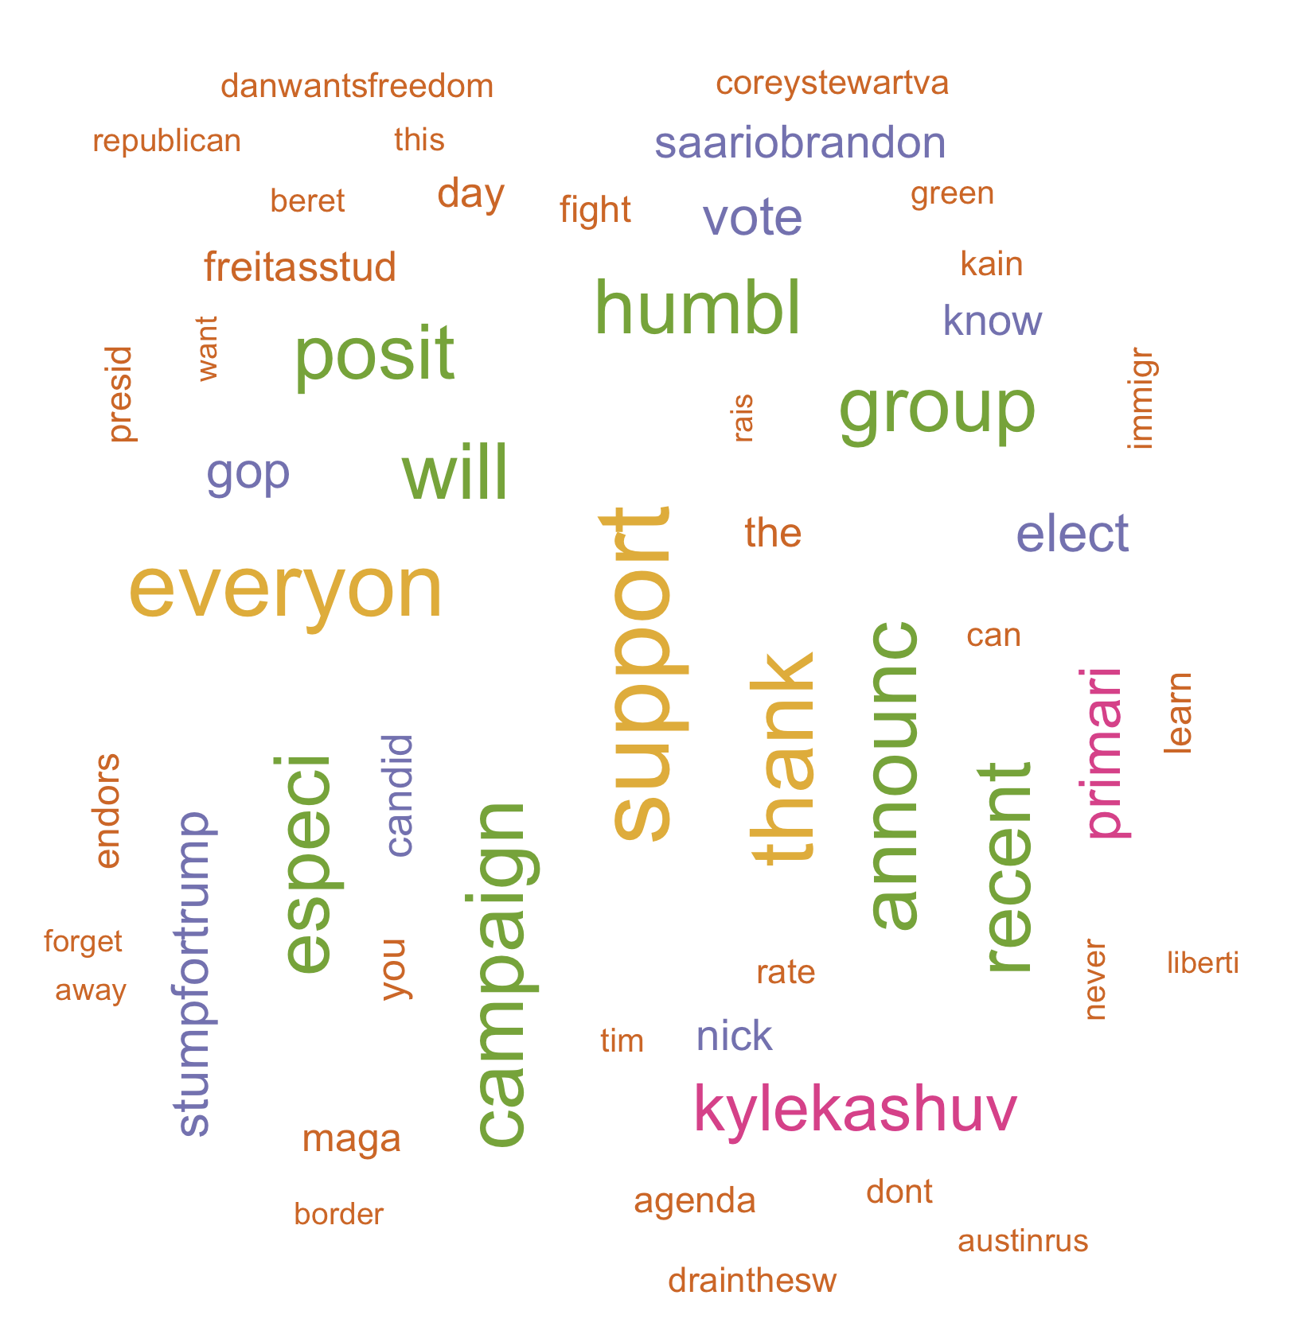

**List of The Top Ten Frequently used Words**

# ## word freq ## beret beret 1459 ## green green 1459 ## stumpfortrump stumpfortrump 1458 ## hes hes 1414 ## republican republican 1392 ## want want 1375 ## nra nra 1350 ## former former 1337 ## parti parti 1333 ## rise rise 1331

# Plot of Words that Appear at least 250 times

##   
## Attaching package: 'ggplot2'

## The following object is masked from 'package:NLP':  
##   
## annotate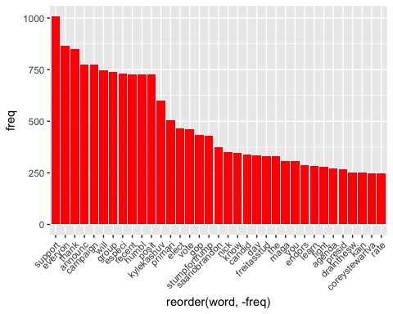

## Words Associated with

To find out what words are associated with the candidates, I use a function called FindAssocs() on the dataset. For any given word, findAssocs() calculates its correlation with every other word in the dataset. Scores range from 0 to 1. A score of 1 means that two words always appear together, while a score of 0 means that they never appear together.

# which words are associated with "Corey Stewart"  
   
 findAssocs(tdm,"coreystewartva", 0.1)

## $coreystewartva  
## mattsoursemit wcve correct edwgillespi googletrend   
## 0.32 0.30 0.29 0.29 0.29   
## trumper antimass migrat protrump williedeutsch   
## 0.29 0.29 0.29 0.29 0.28   
## found multipl claim analysi craigcarp   
## 0.28 0.28 0.27 0.26 0.25   
## rollinreising vahousegop reject kessler run   
## 0.22 0.22 0.21 0.21 0.20   
## dumpstewart libertyhangout week last disavow   
## 0.20 0.19 0.18 0.17 0.17   
## nazi speedbliss answer easi mfeuz   
## 0.17 0.17 0.16 0.16 0.16   
## pan oppon jennaportnoy larryoconnor jason   
## 0.16 0.15 0.15 0.15 0.15   
## rage seem paul presum cssc   
## 0.15 0.14 0.14 0.14 0.14   
## prorand super urg realpotus titl   
## 0.14 0.14 0.14 0.14 0.14   
## unaccept louiescataglia antisemit nehlen anncoult   
## 0.14 0.14 0.13 0.13 0.13   
## sarahpalinusa virginiacorey june for kfile   
## 0.13 0.13 0.12 0.12 0.12   
## racist benshapiro view bluevirginia realtjrobert   
## 0.12 0.12 0.12 0.12 0.12   
## doest org etc cernovich jfradioshow   
## 0.12 0.12 0.12 0.12 0.12   
## tax candid interest refus callstevejoyc   
## 0.11 0.11 0.11 0.11 0.11   
## mosqu email choos condemn disqua   
## 0.11 0.11 0.10 0.10 0.10   
## doubledigit releas yvonneburton belgiantrump   
## 0.10 0.10 0.10 0.10

findAssocs(tdm,"nickforva", 0.1)

## $nickforva  
## cool advoc hirschfeldva wow democrat   
## 0.90 0.85 0.71 0.68 0.62   
## race realli oppon this mass   
## 0.61 0.58 0.53 0.49 0.34   
## murder deleg address indivisibleva plan   
## 0.34 0.31 0.31 0.16 0.15   
## also   
## 0.12

findAssocs(tdm,"ewjacksonsr",0.1 )

## $ewjacksonsr  
## worth kassydillon two bluevirginia wfir   
## 0.49 0.49 0.45 0.31 0.31   
## unfavor lillianmboyd cook favor challeng   
## 0.29 0.29 0.29 0.25 0.23   
## trend wussi chaznuttycomb rank safe   
## 0.20 0.20 0.20 0.20 0.20   
## percent crazi both nehlenlov candidat   
## 0.20 0.20 0.20 0.20 0.20   
## strong were there interview month   
## 0.19 0.18 0.16 0.16 0.14   
## advic earli pass less kick   
## 0.14 0.14 0.14 0.14 0.13   
## enough past nomine with season   
## 0.13 0.12 0.12 0.12 0.12   
## gonna vagop googl poll almost   
## 0.10 0.10 0.10 0.10 0.10   
## roanokecolleg   
## 0.10

# Number of Tweets per Day

##   
## Attaching package: 'scales'

## The following object is masked from 'package:readr':  
##   
## col_factor

